**Mr. Visca’s: Calculus (Chpt 2.4)**

**Chpt 2 – Day 9 Avgerage Rate of Change**

**Average Rate of Change:**

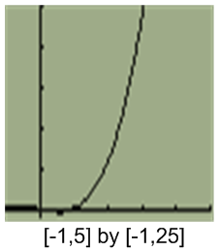Find the average rate of change of f(x) = x3 - x over the interval [1,3]

Ultimately, it’s the ___________________ from points were ______________________________

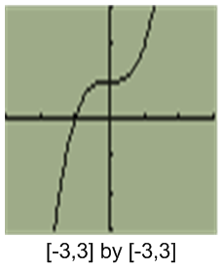

Find the average rate of change of f(x) = x3 + 1 over the interval [-1,1]

**Slope and Tangent line:**

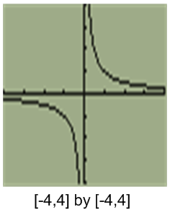Find the slope of the curve of f(x) = 1/x at the point where x = a; where does the slope = -1/4? What happens at those points? And what at point (a, 1/a) for different values of a?

Find the slope of the curve of f(x) = x2 + 2 at x = a; describe what's happening to the tangent as a changes.

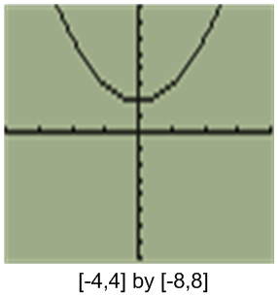

*HW: Section 2.4*

*#s 2,4,6,8,20,22*